Ultimate Hive, Sqoop and Impala

Hive options: -

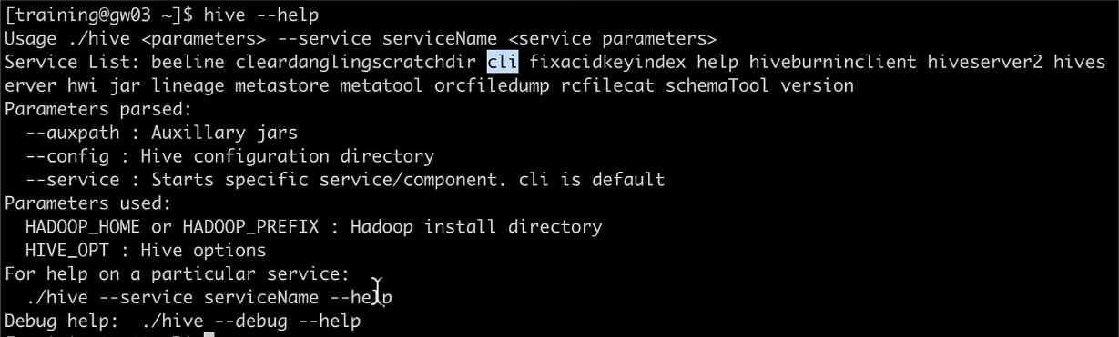



Exporting hive query output: -



Hive CLI properties: -

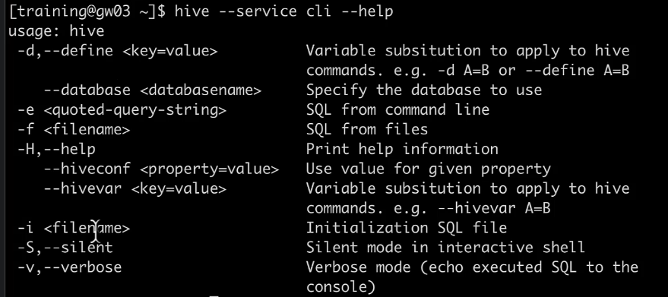

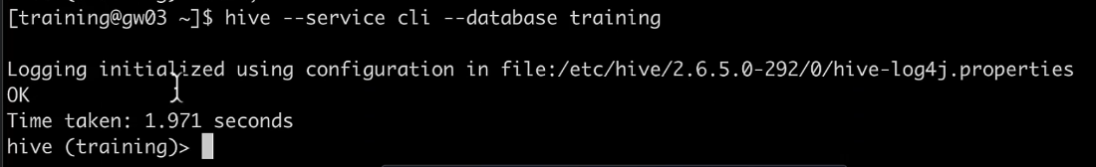

Hive properties: -

Execution engine: -

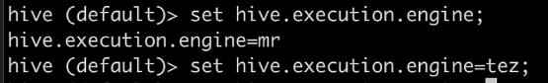

Change property while launching hive: -



Hive CLI History: -

* Ctrl + r 🡪 It will take you to the reverse-i-search
* Just start typing the command you are looking for
* Hit enter when you get your command it will execute

.hiverc file: -

* This file runs by default when you launch hive

Running Hadoop command from Hive shell: -

